So whenever the ball falls of the platform or goes out of the plaform we re going to say game over and then we don't want the ball to control anymore
We want the ball to fall down
We can do so by many ways but we are going to do through recasting or recasting facility in Unity
So what we are going to do is from the center of the ball e will creaate a ray aand cast that ray downward
and we will constantly check is that ray is colliding with any other game object tht it is colliding with any other game object or that it is colliding with any platform aand when the ball goes out of platform ,the ray will not collide with the platform anymore so then we want the ball to fall down and we don't want the player to control the ball anymore and we want the Game over to happen
So lets go and start coding
Now we will see how the rays goes and how it willl affect our situation
Sop first what we are going to do is create another variable gameOver
and noww in start method we set the gameOver to the false
OfCourse in the beginning
void Update()
{
if(!started)
{
if (Input.GetMouseButtonDown(0))
{
rb.velocity = new Vector3(speed, 0, 0);
started = true;
}
}
if (Input.GetMouseButtonDown(0) && !gameOver)
{
Debug.Log(started);
SwitchDirection();
}
}
In marked yellow area above we modify the condition such that when gameOver is false (means the game is still being played ) then the block will run because of not operator
Of course we don't want that the ball should change direction when the Game is over and we don't waant the paayer to play it anymore
So now we need ot do is raycasting
So to do raycasting we will call a static method may be of Physics inside the update method
and the e need three paarameters for this static method
First is the point from which the point is
Now we will give the direction to which the ray will go to lets say we can say we re going left, right , up and down abd then we set the parameter for how far the ray will travel.

So for the first parameter we will give transform.position which give us the correct position of teh object the script os attched to

For second parameter that is direction we will give the direction of down according to the Coordinate axis or the orientation of our object (who knows)so we give it the value Vector3
and now for the distance we are going to give 1f so w want the unit t be 1 unit long
All the coding is shown below
void Update()
{
if(!started)
{
if (Input.GetMouseButtonDown(0))
{
rb.velocity = new Vector3(speed, 0, 0);
started = true;
}
}
Physics.Raycast(transform.position, Vector3.down, 1f);
if (Input.GetMouseButtonDown(0) && !gameOver)
{
Debug.Log(started);
SwitchDirection();
}
}
So here we are creating a ray the oigin position of the ray is the position of the ball . The ray goes donward and if of length 1f
So now we need to check is this ray is colliding with other gameobject

So the raycast method returns true if a ray is colliding with a gameobject otherwise false
so now we will place the raycast method in if condition with not logic applied on it and then in block the gameOver is set to true. If set to true then green marked area above will run or there will be no direction change after any click on the screen

No our code will look like below

void Update()
{
if(!started)
{
if (Input.GetMouseButtonDown(0))
{
rb.velocity = new Vector3(speed, 0, 0);
started = true;
}
}
if(!Physics.Raycast(transform.position, Vector3.down, 1f))
{
gameOver = true;
}
if (Input.GetMouseButtonDown(0) && !gameOver)
{
Debug.Log(started);
SwitchDirection();
}
}
Note:-
I think the Vector3.down assumes a specific axis direction down

Now when our ball goes outside the platform then we cannot change its position and the ball goes

Now we want that when our ball go outside the platform then its velocity gets changed and it falls down in a high velocity
so inside the condition of ray casting we initialise rb.velocity to a Vector object with x , z as 0 and y with a high negative value because we want it to go down after it

Now the problem we are seeing is that when the ball nreaches the platform edge then it stopss at the edge for some second and then it goes down like below How to solve it
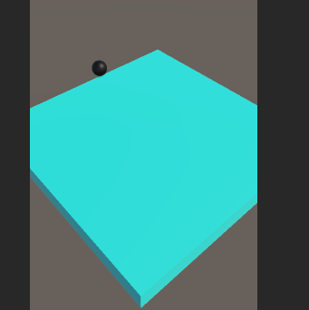
So whaat we can do is that we can check from which position we are casting the ray
So in order to see the ray you are casting what we can do is write Debug DrawRay
It will visually show that in which position it is actually going
in 1st parameter we tell teh its poistion whihc we will set to the ball position aand second parameter we set direction and third parameter we tell color so red color will be creted here down ward so we can see visually teh position from which ray is casted
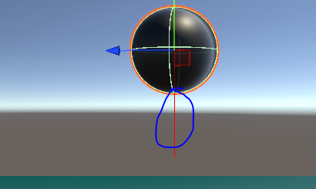
the marked aone is the ray used for debug
you know both of teh plaatform and the ball has rigidbody or collidor attached to them
this is part of the unity system
SO there's a friction between as ball is pushing downward and in retaliation pltform will push up due to which friction is created and since no rotation is there on the ball as rotation is freezed and when it reaches the edge until any part touch each other there will be friction between them and ball movement of ball will be slowed so what we need to do is make the friction between them exactly zero
so for that we need to create a physics material
in the Phusucs material by right clicking and then create>Physics material
We name it as Zerofriction
Now click on it and in inspector set dyanamic friction and static friction to zero
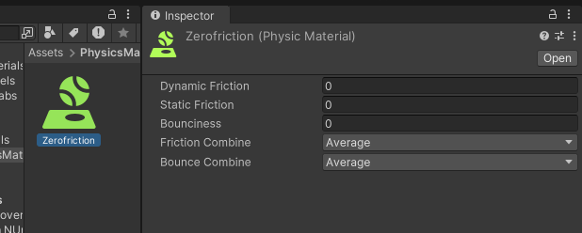
Now drag and drop the Zerofriction to the material field of the collidor of both ball and platform as shown below
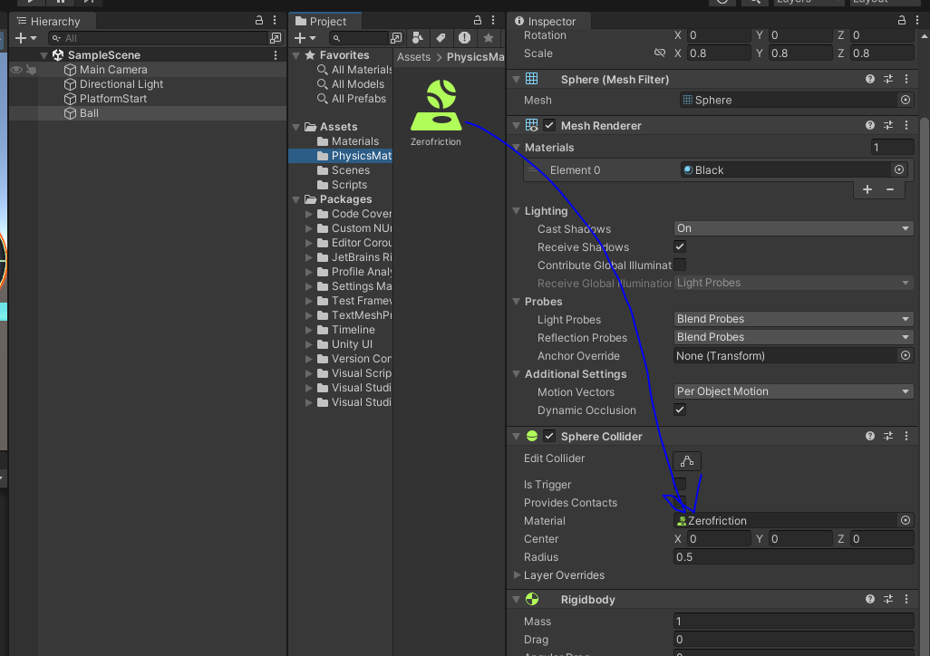
Now it will fall off the plaform without any friction due to which it will fall without any delay
In next lesson we will see how the camera can fllow the ball and how we can randomly spawn platform

